Get Notified When Files are modified.

Steps

1. Open Power Automate and click New Flow

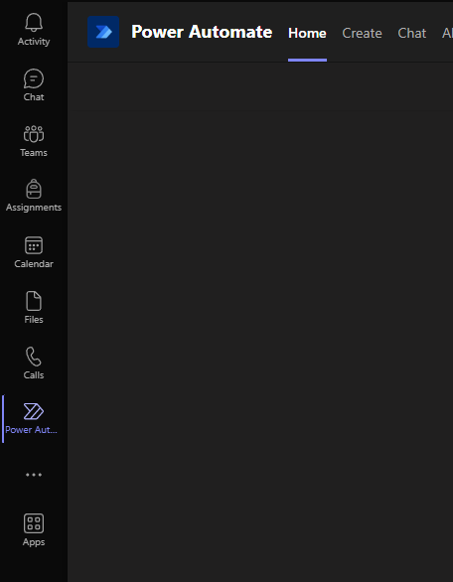

1. You have 3 options, lets choose Microsoft Teams Templates:”

Select : Start an approval when a file is added to sharepoint.



Click next :

Fill below information :

Channel this flow will apply too

The folder to which changes are made

And email id’s of those who need to be notified.

Click on create Flow.

Select done and open Home tab where you will see your flow.



Click on the 3 dots and edit the flow

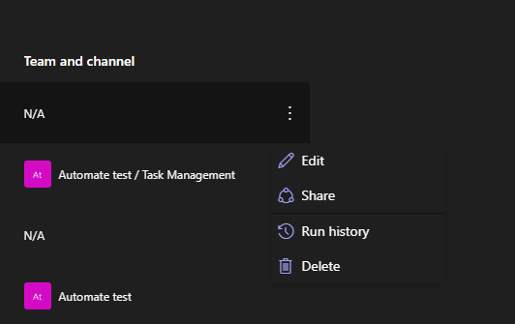

This is how your flow will look.

Edit each step to your liking.

This flow will notify and ask for approval on creation of a file.

New flow can be created with modification and a separate one for deletion of files.

This flow can be modified to either send approval in email , on chat or both. Here notification is created on both channels and hence the flows are branched out on create approval step.

Add Steps as below :

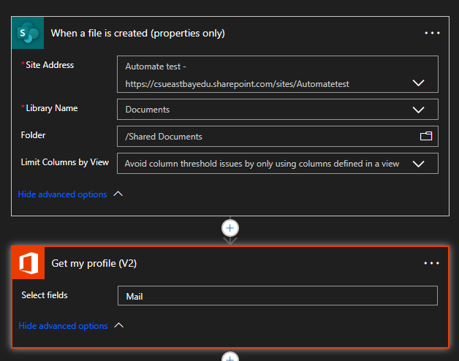

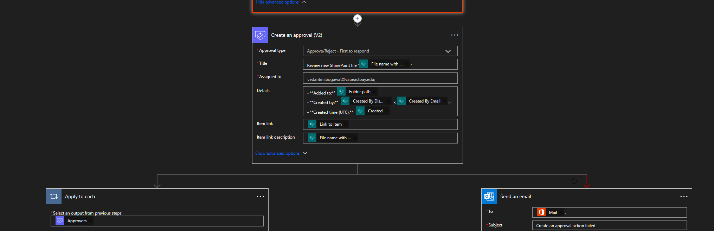

Click on save and your flow will be deployed.

You can manually test as well as test automatically to check the working of your flow which is highly recommended.

Testing :

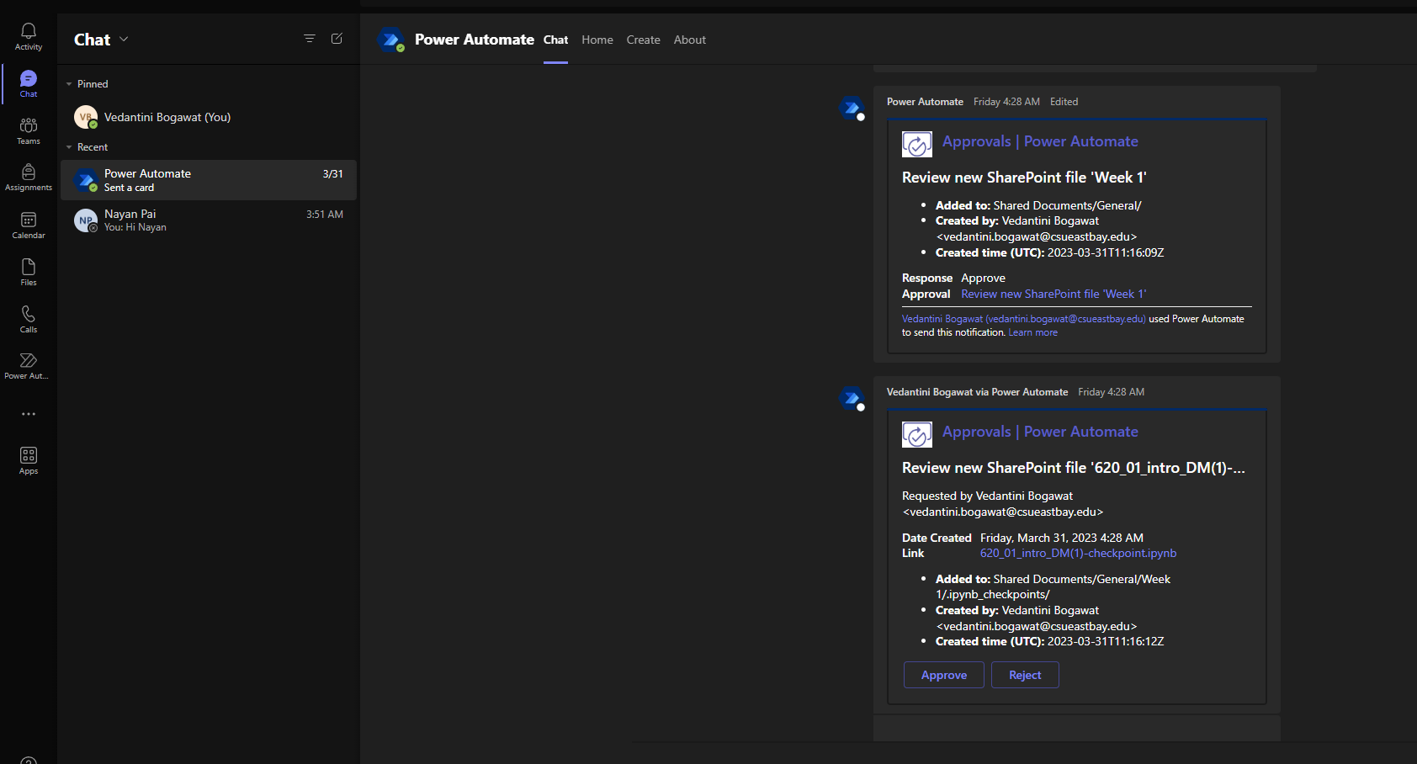

The above Approval and Reject was done from the Teams Chat.

Same can be achieved via email.

Please stay tuned for a video tutorial on the same which will help you follow the steps as I implement it.